CREEKSIDE’S TEACHING NOTES for Sunday, October 19, 2014

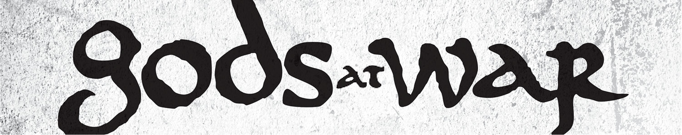

*“Idolatry is the most discussed problem in the Bible and one of the most powerful spiritual and intellectual concepts in the believer’s arsenal. Yet for Christians today it is one of the least meaningful notions…*”

Os Guinness

“Now fear the Lord and serve him with all faithfulness. Throw away the gods your ancestors worshiped beyond the Euphrates River and in Egypt, and serve the Lord. But if serving the Lord seems undesirable to you, then choose for yourselves this day whom you will serve, whether the gods your ancestors served beyond the Euphrates, or the gods of the Amorites, in whose land you are living. But as for me and my household, we will serve the Lord.”

Joshua 24:14-15 (p. 221)

1. REALIZE WE ALL WORSHIP SOMETHING:

Joshua presents three worship options . . .

1. Worship the gods of your ancestors

2. Worship the gods of the people around you.

3. Worship our God Yahweh

There is no *“I am not going to worship anything”* option.

Idolatry is the most commonly discussed sin in all of Scripture.

Elyse Fitzpatrick

OLD TESTAMENT:

**“You shall have no other gods beforeme.**

Exodus 20:3 (p. 70)

“I am the LORD your God, who brought you out of the land of Egypt, out of the house of slavery. You shall have no other gods before Me.”

Exodus 20:2-3

Do not turn to idols or make for yourselves molten gods;   
I am the LORD your God.

Leviticus 19:4 (p. 110)

Let all those be ashamed who serve graven images, who boast themselves of idols; worship Him . . .

Psalm 97:7 (p. 554)

NEW TESTAMENT:

Do not be idolaters as some of them were.

1 Corinthians 10:7 (p. 1058)

Therefore, my beloved, flee idolatry.

1 Corinthians 10:14 (p. 1059)

Now the deeds of the flesh are evident, which are . . . idolatry.

Galatians 5:19-20 (p. 1078)

Little children, guard yourselves from idols.

1 John 5:21 (p. 1132)

2. IDENTIFY THE GODS THAT WAR FOR YOUR HEART:

Idolatry lies at the heart

of every besetting sin.

An idol is whatever you look at and say in your heart of hearts, “If I have that then I’ll feel my life has meaning, then I’ll know my life has value, then I’ll feel significant and secure.”

- Timothy Keller

If anything becomes more fundamental than God to your happiness, meaning in life, and identity then it is an idol.

- Timothy Keller

God Identity Questions . . .

1. What are you most disappointed with?

2. What do you sacrifice your time and money for?

3. Where do you go when you’re hurt?

3. MAKE A WORSHIP CHOICE TODAY:

“ . . . then choose for yourselves this day whom you will serve, . . .”

Joshua 24:15 (p. 221)

Choose this day means . . .

• Remember what God has done vs 2-13

• Recognize who God is

Joshua said to the people, . . . “He is a holy God. He is a jealous God. . . . he has been good to you.”

Joshua 24:19-20

• Reject all other gods.

“Now then,” said Joshua, “throw away the foreign gods that are among you and yield your hearts to the LORD,   
the God of Israel.”

Joshua 24:23