CREEKSIDE’S TEACHING NOTES for Sunday, November 2, 2014

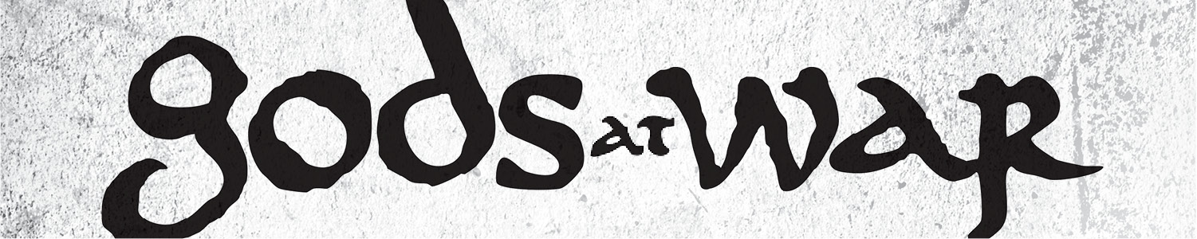

gods of love

An idol is whatever you look at and say in your heart of hearts, “If I have that then I’ll feel my life has meaning, then I’ll know my life has value, then I’ll feel significant and secure.”

- Timothy Keller

We may think that the gods are always bad things

but that is almost never the case.

Idols are most often good things, that have become ultimate things, that then turn into controlling things.

Love is the effort and desire

to make someone else

everything they were created to be.

Tim Keller

We must love everyone.

We must love God.

But we are not to worship anyone.

We are only to worship God.

The story of Jacob, Leah, and Rachel

Genesis 29 (p. 28)

Now Laban had two daughters; the name of the older was Leah, and the name of the younger was Rachel. Leah had weak eyes, but Rachel had a lovely figure and was beautiful. Jacob was in love with Rachel and said, “I’ll work for you seven years in return for your younger daughter Rachel.”

The only way to dispossess the heart of an old affection is by the expulsive power of a new one.

Thomas Chalmers

Laban said, “It’s better that I give her to you than to some other man. Stay here with me.” So Jacob served seven years to get Rachel, but they seemed like only a few days to him because of his love for her.

Genesis 29:16-20

We look to sex and romance

to give us the transcendence we used to get from God.

Ernest Becker

“He worships the ground she walks on”

When the Lord saw that Leah was not loved, he enabled her to conceive, but Rachel remained childless. Leah became pregnant and gave birth to a son. She named him Reuben,for she said, “It is because the Lord has seen my misery. Surely my husband will love me now.”

She conceived again, and when she gave birth to a son she said, “Because the Lord heard that I am not loved, he gave me this one too.” So she named him Simeon.

Again she conceived, and when she gave birth to a son she said, “Now at last my husband will become attached to me, because I have borne him three sons.” So he was named Levi.

She conceived again, and when she gave birth to a son she said, “This time I will praise the Lord.” So she named him Judah. Then she stopped having children.

Genesis 29:31-35

The messianic promise is given to Judah in Genesis 49:8-12 (p. 50)

Jesus is born through Leah’s son Judah - Matthew 1:2 & 16 (p. 889)

FOUR OPTIONS WHEN LOVE FAILS

1. Look for someone else to give you what you want.

2. Blame yourself for your pain and rejection.

3. Blame the world and become cynical and small.

4. Reorient the focus of your life toward God.

WHY “NOT LOVING GOD FIRST” IS SO DANGEROUS

1. You were made to love God foremost. To not love God foremost is to violate who he is and who you are.

2. To love someone else in the place of God is to put a lot of pressure on the person to be to you what only God can be to you.

3. Get God out of place in your life and you get everything out of place in your life.