CREEKSIDE’S TEACHING NOTES for Sunday, March 27, 2016

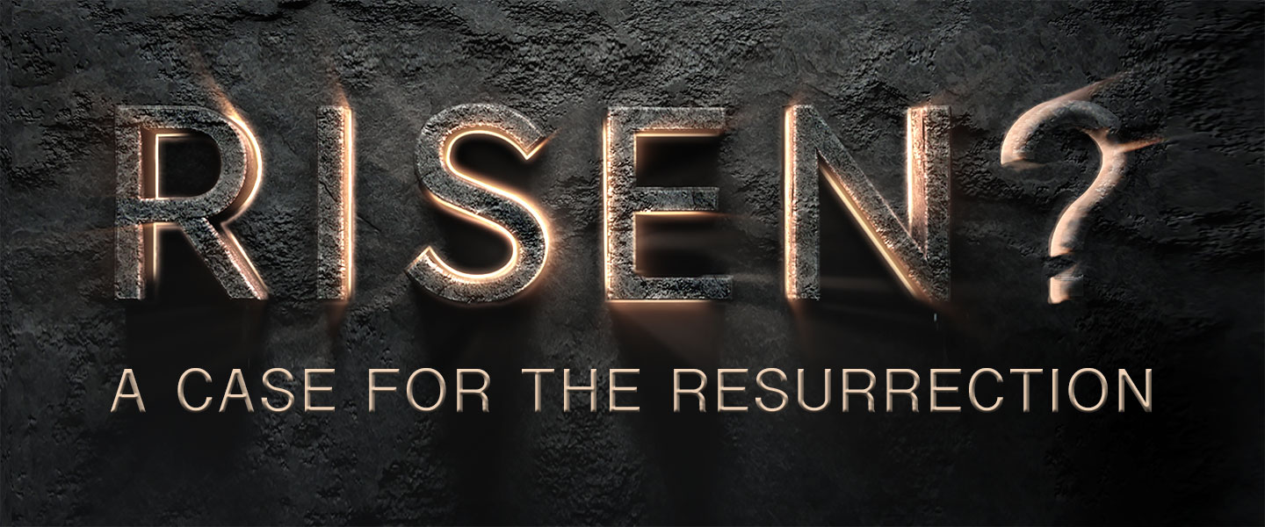

And if Christ has not been raised,

our preaching is useless and so is your faith.

1 Corinthians 15:14

If the dead are not raised, ‘let us eat and drink, for tomorrow we die.’

1 Corinthians 15:32

He answered, “A wicked and adulterous generation asks for a sign! But none will be given it except the sign of the prophet Jonah. For as Jonah was three days and three nights in the belly of a huge fish, so the Son of Man will be three days and three nights in the heart of the earth.

Matthew 12:39-40

The Jews then responded to him, “What sign can you show us to prove your authority to do all this?” Jesus answered them, “Destroy this temple, and I will raise it again in three days.” They replied, “It has taken forty-six years to build this temple, and you are going to raise it in three days?” But the temple he had spoken of was his body. After he was raised from the dead, his disciples recalled what he had said. Then they believed the scripture and the words that Jesus had spoken.

John 2:18-22

CHRISTIANITY’S TEST FOR ITS VERACITY IS NOT A SUBJECTIVE TEST; WHAT DO YOU THINK OR FEEL ABOUT IT? IT IS AN OBJECTIVE TEST; WHAT HAPPENED?

THREE UNIVERSAL FACTS ABOUT THE RESURRECTION

FACT #1 – JESUS WAS EXECUTED BY CRUCIFIXION

“Suffered the extreme penalty under the reign of Tiberius”

Tacitus (56 – 117 AD)

“condemned him to be crucified.”

Josephus (37 – 100 AD)

“ . . . this first fact is as solid as anything in the ancient history: Jesus was crucified and died as a result. The scholarly consensus – again, even among those who are sceptical toward the resurrection – is absolutely overwhelming. To deny it would be to take a marginal position that would get you laughed out of the academic world.”

Michael Licona

**FACT #2 – JESUS’ TOMB WAS EMPTY**

• The Jerusalem Factor – Jesus was publicly executed and buried in Jerusalem and then his resurrection was proclaimed in that very same city.

• Matthew, Justin Martyr and Tertullian report that the enemies of Jesus said the body was stolen. Jesus’ enemies admit the tomb was empty.

• The testimony of women that the tomb was empty is not the kind of testimony you would use in that culture to prove anything. Women were not regarded as reliable witnesses. But using this as proof of an empty tomb suggests it is genuine. You tend not to make up stories that weaken your position.

**FACT#3 – JESUS’ DISCIPLES BELIEVED THAT HE RESURRECTED AND APPEARED TO THEM**

We are not saying that the majority of scholars, both believer and skeptic alike, believe that Jesus rose from the dead but rather that they are convinced that the disciples believed that Jesus rose from the dead.

• Oral Tradition – 1 Corinthians 15:3-7

• Writings Of The Apostolic Fathers

• The Martyrdom Of The Disciples – We are not arguing that the resurrection was true because the disciples believed it was true. We are simply stating that the disciples believed it was true. This is significant because they were first hand witnesses of the resurrection. They knew for a fact whether Jesus did or did not rise from the dead. And every one of them went to his death unswerving in their claim that they had seen him, touched him, and talked to him many times in multiple contexts after his crucifixion.

GIVEN THESE THREE FACTS WHAT THEORIES HAVE PEOPLE USED TO PUSH BACK THE TRUTH OF THE RESURRECTION?

1. The Disciples Stole the Body
2. The Disciples Experienced Hallucinations
3. The Disciples Went to the Wrong Tomb
4. The Swoon Theory

My desire to draw close to God was blocked by my own pride and sinfulness, which in turn was an inevitable consequence of my own selfish desire to be in control. Now the crucifixion and resurrection emerged as the compelling solution to the gap that yawned between God and myself, a gap that could now be bridged by the person of Jesus Christ.

Francis S Collins, The Language of God

**SO WHAT IS MY RESPONSE TO**

**THE RESURRECTION OF JESUS?**