CREEKSIDE’S TEACHING NOTES for Sunday, June 12, 2016

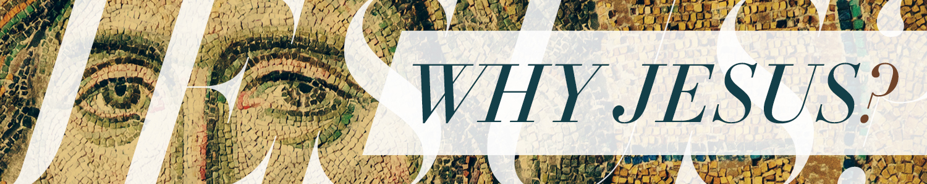

THE POWER COLLISION

John 19:1-42

THE POWER OF THIS WORLD’S KINGDOMS

It Seeks to Dominate

Then Pilate took Jesus and had him flogged. The soldiers twisted together a crown of thorns and put it on his head. They clothed him in a purple robeand went up to him again and again, saying, “Hail, king of the Jews!” And they slapped him in the face.

John 19:1-3

Matthew 27:27-31

It Fights for Position

4Once more Pilate came out and said to the Jews gathered there, “Look, I am bringing him out to you to let you know that I find no basis for a charge against him.” 5When Jesus came out wearing the crown of thorns and the purple robe, Pilate said to them, “Here is the man!”

6As soon as the chief priests and their officials saw him, they shouted, “Crucify! Crucify!” But Pilate answered, “You take him and crucify him. As for me, I find no basis for a charge against him.”

7The Jewish leaders insisted, “We have a law, and according to that law he must die, because he claimed to be the Son of God.”

8When Pilate heard this, he was even more afraid, 9and he went back inside the palace. “Where do you come from?” he asked Jesus, but Jesus gave him no answer. 10“Do you refuse to speak to me?” Pilate said. “Don’t you realize I have power either to free you or to crucify you?” 11Jesus answered, “You would have no power over me if it were not given to you from above. Therefore the one who handed me over to you is guilty of a greater sin.” 12From then on, Pilate tried to set Jesus free, but the Jewish leaders kept shouting, “If you let this man go, you are no friend of Caesar. Anyone who claims to be a king opposes Caesar.” 13When Pilate heard this, he brought Jesus out and sat down on the judge’s seat at a place known as the Stone Pavement (which in Aramaic is Gabbatha). 14It was the day of Preparation of the Passover; it was about noon. “Here is your king,” Pilate said to the Jews.

John 19:4-14

It Battles for Recognition

As soon as the chief priests and their officials saw him, they shouted, “Crucify! Crucify!” But Pilate answered, “You take him and crucify him. As for me, I find no basis for a charge against him.”

7The Jewish leaders insisted, “We have a law, and according to that law he must die, because he claimed to be the Son of God.”

John 19:6-7

12From then on, Pilate tried to set Jesus free, but the Jewish leaders kept shouting, “If you let this man go, you are no friend of Caesar. Anyone who claims to be a king opposes Caesar.”

John 19:12

They used the power of this world to . .

Gain position – Pilate

Express hatred – the soldiers beating Jesus

Remove an enemy – the religious leaders

Control an outcome – “we have a law”

THE POWER OF JESUS’ KINGDOM

It is the Power of Truth and Love

Jesus would submit to the power of this world

to magnify the power of his kingdom,

the power of truth and love.

Crucifixion combined four qualities the Romans prized most in an execution: unrelenting agony, protracted death, public spectacle, and utter humiliation.

Chuck Swindoll

Near the cross of Jesus stood his mother, his mother’s sister, Mary the wife of Clopas, and Mary Magdalene. When Jesus saw his mother there, and the disciple whom he loved standing nearby, he said to her, “Woman, here is your son,”and to the disciple, “Here is your mother.” From that time on, this disciple took her into his home.

Later, knowing that everything had now been finished, and so that Scripture would be fulfilled, Jesus said, “I am thirsty.” A jar of wine vinegar was there, so they soaked a sponge in it, put the sponge on a stalk of the hyssop plant, and lifted it to Jesus’ lips.When he had received the drink, Jesus said, “It is finished.” With that, he bowed his head and gave up his spirit.

John 19:25-30