CREEKSIDE’S TEACHING NOTES for Sunday, August 7, 2016

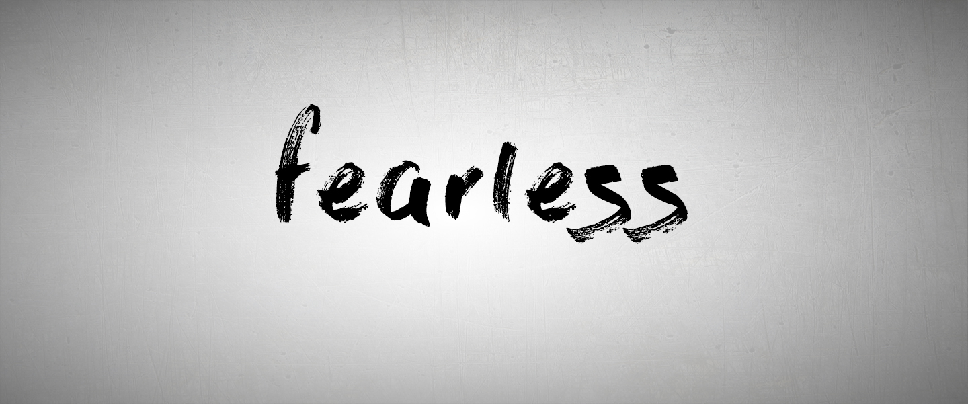

PART 1

MY FUTURE AND GOD’S FAITHFULNESS

**I sought the Lord, and he answered me**

**and delivered me from all my fears.**

Psalm 34:4

The most frequent command in all of Scripture is . . .

“Fear not!”

****FEAR****: An anxious feeling, caused by our anticipation

of some imagined event or actual experience.

Fear is not about the past.

It is experienced in the present.

It is primarily about the future.

We fear because we do not know what the future holds.

We fear because we cannot control everything.

We fear because we feel we face this alone.

HOW DO WE OVERCOME OUR FEAR OF THE FUTURE?

We trust in the faithfulness of God.

He knows the future. He controls everything. He is with me always.

1. RECOGNIZE THAT GOD IS FAITHFUL:

If we are faithless he will remain faithful,

for he cannot deny himself.

2 Timothy 2:13

God is by nature faithful.

He cannot be anything other than who he is.

The LORD is faithful to all his promises

and loving toward all he has made.

Psalm 145:13

God is not human, that he should lie,  
    not a human being, that he should change his mind.  
Does he speak and then not act?  
    Does he promise and not fulfill?

Numbers 23:19

The one who calls you is faithful and he will do it.

1 Thessalonians 5:24

But it was because the Lord loved you and kept the oath he swore to your ancestors that he brought you out with a mighty hand and redeemed you from the land of slavery,from the power of Pharaoh king of Egypt. Know therefore that the Lord your God is God; he is the faithful God, keeping his covenant of love to a thousand generations of those who love him and keep his commandments. But those who hate him he will repay to their face by destruction; he will not be slow to repay to their face those who hate him.

Deuteronomy 7:8-10

2. PERSONALIZE THE FAITHFULNESS OF GOD:

And we know that in all things God works for the good of those who love him, whohave been called according to his purpose.

Romans 8:28

Yet this I call to mind and therefore I have hope:

Because of the Lord’s great love we are not consumed, for his compassions never fail. They are new every morning; great is your faithfulness.

Lamentations 3:21-23

**Then I saw “a new heaven and a new earth,”for the first heaven and the first earth had passed away, and there was no longer any sea. I saw the Holy City, the new Jerusalem, coming down out of heaven from God, prepared as a bride beautifully dressed for her husband. And I heard a loud voice from the throne saying, “Look! God’s dwelling place is now among the people, and he will dwell with them. They will be his people, and God himself will be with them and be their God. ‘He will wipe every tear from their eyes. There will be no more death’ or mourning or crying or pain, for the old order of things has passed away.”**

He who was seated on the throne said, “I am making everything new!” Then he said, “Write this down, for these words are trustworthy and true.”

He said to me: “It is done. I am the Alpha and the Omega, the Beginning and the End. To the thirsty I will give water without cost from the spring of the water of life. Those who are victorious will inherit all this, and I will be their God and they will be my children.

Revelation 21:1-7