**CREEKSIDE’S TEACHING NOTES for Sunday, August 28, 2016**

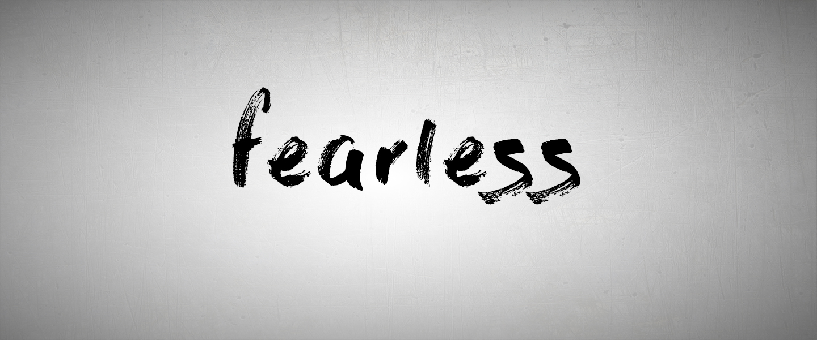

**PART 4**

MY NEEDS AND GOD’S PROVISION

**I sought the Lord, and he answered me**

**and delivered me from all my fears.**

Psalm 34:4

Fearing that our needs may not be met is called . . . WORRY.

Worry is fear searching for a cause.

Psalm 37:1 Do not fret

Psalm 37:7 Do not fret

Ecclesiastes 11:10 Banish anxiety from your heart.

Matthew 6:25 Do not worry

Matthew 6:31 Do not worry

Matthew 6:34 Do not worry

Luke 12:2 Do not worry

Luke 12:29 Do not worry

But make up your mind not to worry.

Luke 21:14

THERE ARE TWO ACTIONS

THAT WILL HELP US WHACK THE WORRY.

1. It’s About What We See.

2. It’s About What We Seek.

1. IT’S ABOUT WHAT WE SEE:

“Therefore I tell you, do not worry about your life, what you will eat or drink; or about your body, what you will wear. Is not life more than food, and the body more than clothes? Look at the birds of the air; they do not sow or reap or store away in barns, and yet your heavenly Father feeds them. Are you not much more valuable than they?Can any one of you by worrying add a single hour to your life?

“And why do you worry about clothes? See how the flowers of the field grow. They do not labor or spin. Yet I tell you that not even Solomon in all his splendor was dressed like one of these. If that is how God clothes the grass of the field, which is here today and tomorrow is thrown into the fire, will he not much more clothe you—you of little faith? So do not worry, saying, ‘What shall we eat?’ or ‘What shall we drink?’ or ‘What shall we wear?’

Matthew 6:25-31

**God shall supply all your needs according to His riches**

**in glory in Christ Jesus.**

Philippians 4:19

Jehovah-Jireh is a name for God.

It means **“The Lord who provides.”**

2. IT’S ABOUT WHAT WE SEEK:

It’s about your ambition.

**For the pagans run after all these things, and your heavenly Father knows that you need them. But seek first his kingdom and his righteousness, and all these things will be given to you as well.**

Matthew 6:32-33

What are you after in life?

**************************

**Therefore do not worry about tomorrow,**

**for tomorrow will worry about itself.**

**Each day has enough trouble of its own.**

Matthew 6:34

• Trouble is inevitable

• Worry doubles trouble

**Cast all your anxiety on him**

**because he cares for you.**

 1 Peter 5:7